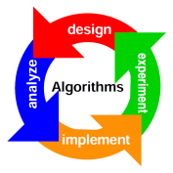
ALGORITHMS
To make a computer do anything, you have to write a computer program. To write a computer program, you have to tell the computer, step by step, exactly what you want it to do. The computer then "executes" the program.
What are algorithms?
In programming, algorithms are the set of well-defined instruction in sequence to solve a program. An algorithm should always have a clear stopping point.
Qualities of a good Algorithm:
1. Inputs and outputs should be defined precisely.
2. Each steps in algorithm should be clear and unambiguous.
3. Algorithm should be most effective among many different ways to solve a problem.
4. An algorithm shouldn't have computer code. Instead, the algorithm should be written in such a way that, it can be used in similar programming languages.
An algorithm to add two numbers entered by user
Step 1: Start
Step 2: Declare variables num1, num2 and sum.
Step 3: Read values num1 and num2.
Step 4: Add num1 and num2 and assign the result to sum.
sum←num1+num2
Step 5: Display sum
Step 6: Stop
REAL LIFE Application (Calling a friend on the telephone)
- Pick up the phone and listen for a dial tone
- Press each digit of the phone number on the phone
- If busy, hang up phone, wait 5 minutes, jump to step 2
- If no one answers, leave a message then hang up
- If no answering machine, hang up and wait 2 hours, then jump to step 2
- Talk to friend
- Hang up phone
Lamp doesn’t work
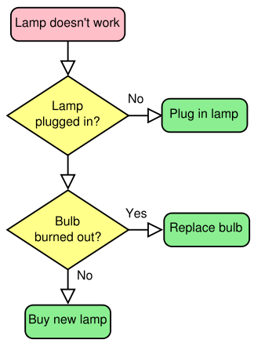
- Check the Lamp
- If Lamp doesn’t work
- Check the lamp whether plugged in or not
- If answer is NO, plug it in and go to 1st step
- If answer is YES, go to next step.
- Check the bulb whether burned out or not
- If answer is YES, Replace the bulb and go to Step 1
- If answer is NO go to Next Step.

My videos | My website

